Prismatic TTRPG – Early Draft
***Disclaimer: All AI or Stock Photo Art is purely used in the sense of having some sort of mood board and imagery to break apart the text, and will be phased out***

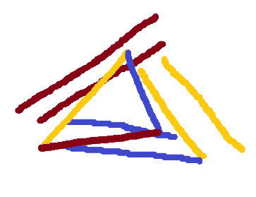
Prima
The World’s Font
“The night sky buzzes and hums with energy as the atmosphere itself carries a primal weight of creation, destruction, and flow; reflecting the proudest ambitions and deepest fears of the onlookers below. Despite the clouds obscuring the moon and stars, countless glittering particles bathe the landscape in every color imaginable – and many beyond imagination”

The very fabric of the Prismatic Realm and its cosmos above is woven in the language of Prima. Prima is energy in its most raw form – entropic, transformative, constructive; untainted by bias or intent.

Prima is found everywhere in the natural (and unnatural!) world – as plentiful as it is precious. At a glance, it appears like a brilliant white plasma of sorts. A deep pearlescent hue reveals itself upon closer inspection, hypnotically emanating every color of the rainbow. Prima is most prevalent in high in WORLDNAME’s atmosphere – becoming increasingly dense as the atmosphere itself becomes more thin and especially concentrated on the evenings of cosmological events. Poets and Romantics wax endlessly about this phenomenon – perhaps comparing a dear lover’s eyes to ‘all the prima in the sky’. Prima also exists and seems to flow within and without the bodies of all living creatures, imbuing them with life. Many would consider the soul to be woven in prima. Others would compare prima moreso to blood or bile – simply another mundane component of a living body. Prima’s cosmological and biological ties lie at the root of endless debate as to whether Prima is arcane or scientific; sacred or mundane.
These debates and technicalities, however, have little bearing on the fundamental thesis of the world and perhaps existence itself.

Prima – that is to say, energy in its purest form made manifest; free of bias, morality, or intent – dictates the very shape of the world. Innovation and technology are built upon an understanding of Prima. Landscapes, weather patterns, and ecosystems are sprung forth by a region’s prima just as much – if not moreso than - a region’s temperature or moisture. Economies, architecture, literature, culture, and even the physical traits and deepest primal instincts of all mortal creatures seem to be shaped by the Prima. Those who look at history on the scale of aeons also argue the opposite is true as well; though many would call the idea of a city changing the prima of an entire region poetic nonsense at best, a grand conspiracy at worst.

To exist in the Prismatic Realm is to exist within a world of Prima. A forceful caster who manipulates the natural order of the world to create great bolts of lightning and fiery explosions would not hesitate to admit as much. A robust fighter whose pride lies in robustness and resilience would make the argument that the change he enacts through his body is exactly that, no Prima involved – but a savvy observer would correctly point out that this is no more or less rooted in the channeling of Prima than the abilities of the aforementioned caster.

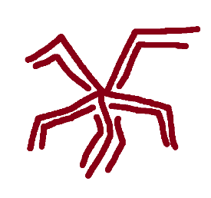
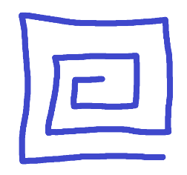
Prisma
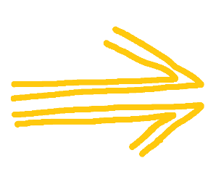
Font stained by intent
“A wise old wizard and his three apprentices come upon a stone wall blocking their path. ‘Let’s destroy it! I love a good explosion!’ proposes the first apprentice, bathed in a fiery red aura. ‘No need; I can easily create a door and improve this gaudy wall’ the second interjects, his hand enveloped in a deep, rigid blue. ‘Both good ideas, but I can change the wall into a gas. Or perhaps water? That’d be a lot more fun’ the third chimes in, as electric yellow sparks leap from his wand. The old wizard, meanwhile, simply walks around the wall.
- From Foundations of Prismatic Theory, Chapter 1, First Page, every edition since the First

It is an undeniable, axiomatic truth that the realm of WORLDNAME is built upon the foundation of Prima.
That the realm’s ecosystems and geography are defined by the Prima present in each region. That living creatures, cultures, economies, and societies are woven by Prima – taking it in and out as naturally as the air we breathe.
And yet…Prima – the raw energy that’s been described thus far – is almost entirely unused and unseen in day-to-day life. Moreso an abstract phenomenon in the stars above and a footnote in a physics calculation than a concrete reality.
Asking an Artificer to create a suit powered by Prima is akin to asking for a machine powered by energy. Is this vague “energy” the release of potential energy stored in gasoline? The biological output of a creature’s limbs? The raw kinetic output of hydroelectricity?
Energy, in any usable and comprehensible form, has character. Shape. Definition. The way it interacts with the world defines its form and function, even if it all stems from the same underlying principle

Prima follows this same idea. It is indeed a quantifiable amount of Prima that causes the winds to blow and a heart to beat, but the language of Prisma that allows these events to be properly understood.
Prisma is created through the imprinting of Intent onto Prima as it comes into contact with the material (and immaterial!) world. This process a called staining. Prima that drifts into an ocean is stained by the winds and waves – taking on an identity of flow and freedom. Prima in an ancient forest, crystalized over the aeons, is stained by the essence of creation and countless stories untold. Prima in a harsh, volcanic waste becomes entropic and excitable; fully embracing the chaotic cycle of decay in the region. Once Prima becomes stained by the world around it, it becomes impossible to ‘un-stain’ in any practical sense of the word. Even the mere intent of trying to do such a thing would, paradoxically, only serve to more deeply stain the Prisma into another shape and increase the complexity of the equation.
This principle is even more observable in the immaterial world. All living creatures channel Prima a byproduct of being alive. However, one would be hard-pressed to find a being devoid of intent, bias, or personality. And thus, every living creature has its own entirely distinct Prisma Font stained by their personality, bias, culture, and story. A being of raw, unstained Prima is widely regarded as a Platonic Ideal – a being detached from worldly ego, writing stories without any font or language.

Prima, for all measurable intents and purposes, exists as Prisma outside of a total vacuum.

Prisma, just like gravity or electricity or heat, follows a grounded, quantifiable set of rules and can be concretely separated into different categories based on its shape. These categories act as a universal language in which anybody from a wizard to an artificer to even a warrior can determine their own personal attunement and the best way to channel Prisma for any particular use-case. The most fundamental of these categories is Lower Order Prisma

Lower Order Prisma
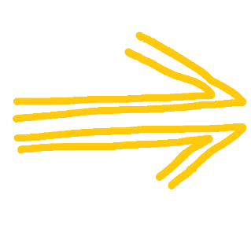

Morphic Prisma
Morphic Prisma is Prima imbued with the color of Flow.
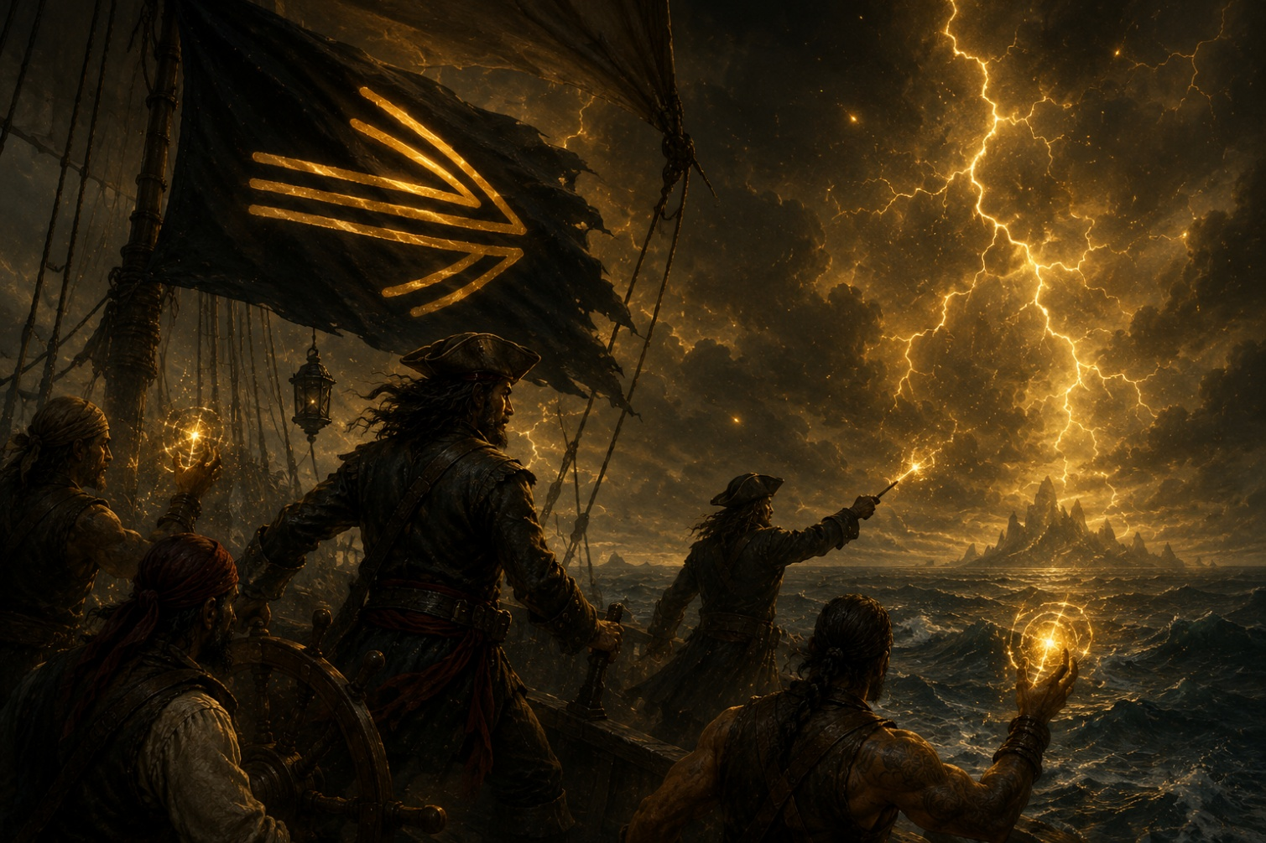
This yellow Prisma presents itself as an atmosphere of fickle, windy, electrifying currents – very closely tied to lightning storms, oceanic environments, and gravity. Cultures shaped by Morphic Prisma are defined as progressive, mercantile, and nomadic. Seafarers who follow the winds of change. Merchant cities with bustling ports – swapping out resources and gladly accepting expats from every background; welcoming new ideas and bold, groundbreaking arts and sciences.

Prima is most potently stained with a Morphic Tint when it comes into contact with Tidestone; a category of malleable rock formed in large bodies of water, carved by the winds and waves. Tidestone, when refined, manifests as a dark glass or metal with a deep purple undertone, and lends itself well to intricate artifices such as daggers, firearms, rapiers, and currency.
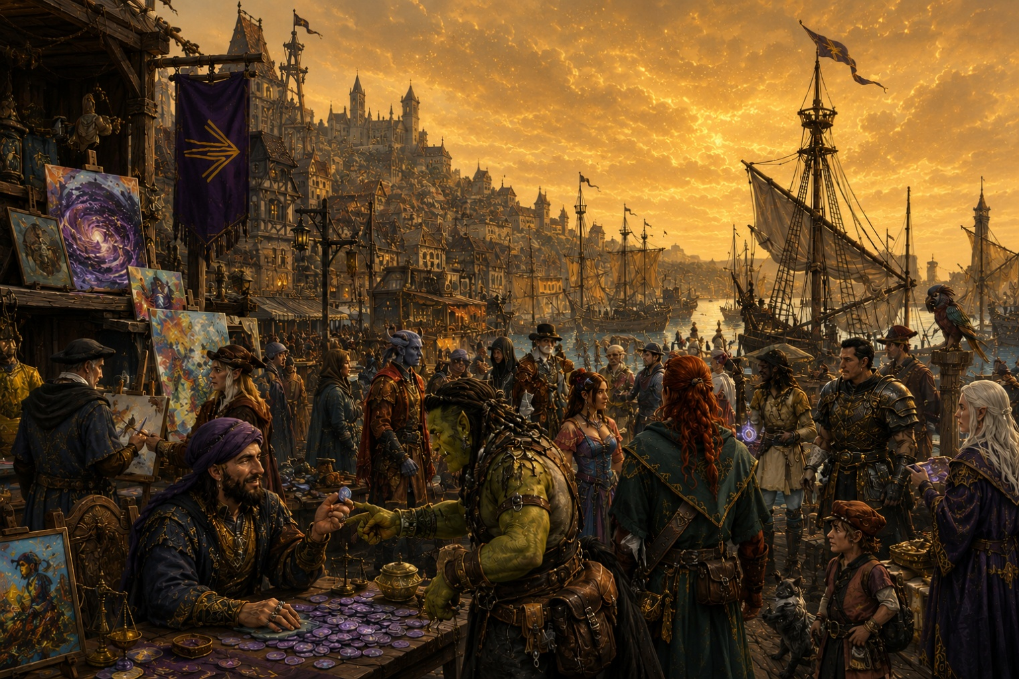
Morphic Prisma is closely tied to Artifice – expression through material and abstract artifacts – and Force – projection of physical and mental will.

To be born with a deeply yellow font is to be blessed by the Deity Morphos

Morphic Prisma is associated with the following traits:
Fickle, Adaptable, Inventive, Progressive, Adventurous, Manipulative, Flighty, Magnetic, Untethered, Witty, Willful, Idealistic, Ungrounded, Opportunistic

Morphic casters tend to have a natural inclination toward:
- Lightning, Wind and Water

- Enchantments and Charms

- Gravity and Spatial Manipulation

- Elemental Control and Manipulation

- Artifice and Constructs

Morphic warriors tend to have a natural inclination toward:
- Damage Avoidance and Redirection, Empowerment through Charms

- Tactical Advantage through Positioning

- Adaptability over Brute Force

- Precise weapons with finesse such as guns, crossbows, daggers, and rapiers

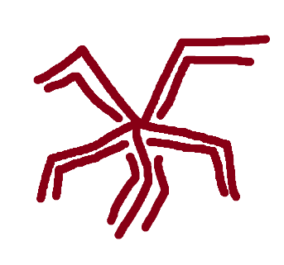
Entropic Prisma
Entropic Prisma is Prima imbued with the color of Entropy.
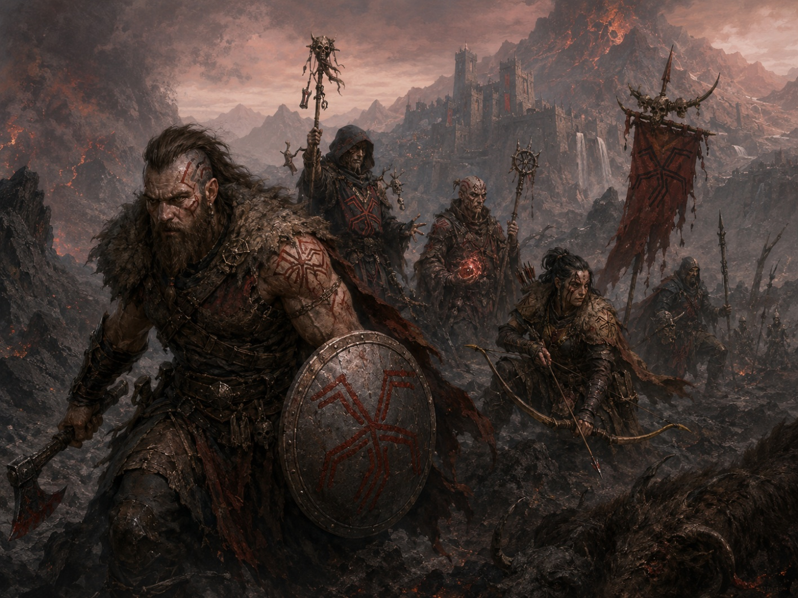
This deep red Prisma presents itself as an atmosphere of weight, decay, and a brutal honesty – very closely tied to fire, volcanoes, and decay. Cultures shaped by Entropic Prisma are defined as meritocratic, fierce, and resilient. Warriors who accept death and dominance as a part of the natural order. Powerful strongholds carved into the landscape – grinding stone into edifice; living creatures into food and elaborate jewelry. These cultures embrace death and decay as cyclical, natural processes that lead to new beginnings – often viewing necromancy and hexes to be just as morally neutral as healing or charms
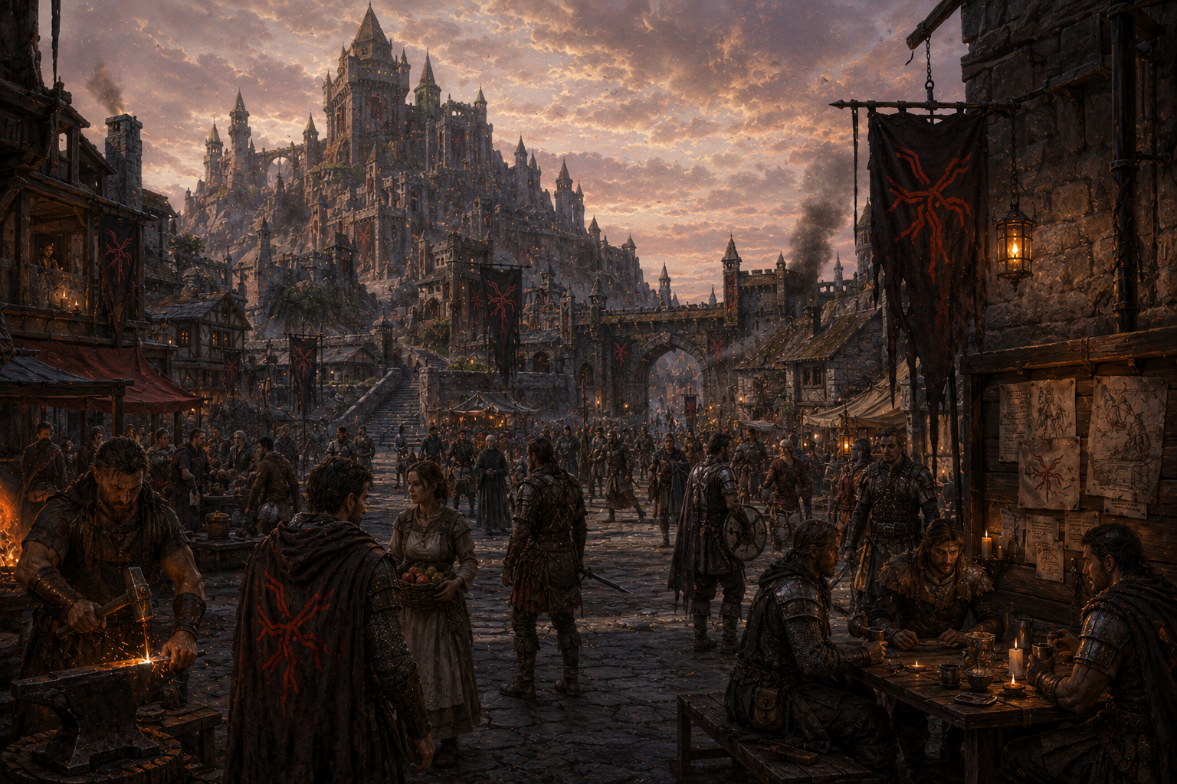
Prima is most potently stained with an Entropic Tint when it comes into contact with Cinderstone; rugged stones formed through the aftermath of heat, magma and ash. When refined, Cinderstone manifests as a silvery glass or metal with a rich green undertone, and lends itself well to effective and honest artifice, such as swords, axes, longbows, and vehicles.
Entropic Prisma is closely tied to Force – projection of physical and mental will – and Body – an attunement to the organic, physical self

To be born with a deeply red font is to be blessed by the Deity Entropos

Entropic Prisma is associated with the following traits:
Resilient, Forceful, Agonistic, Straightforward, Indomitable, Blunt, Driven, Relentless, Reliable, Athletic, Pragmatic, Minimalistic, Content

Entropic casters tend to have a natural inclination toward:
- Fire, Magma, and Decay

- Hexes and Curses

- Death and Necromancy

- Elemental Control and Manipulation

- Empowerment of the Body

Entropic warriors tend to have a natural inclination toward:
- Evaporation of force through reactive counter-magic and deep mental resilience

- Tactical Advantage through dense Auras of Entropy

- Life-Drain Effects and Ability-Draining Curses to outlast and wear down at foes

- Hefty, destructive weapons such as longbows, axes, longswords, war hammers, and maces

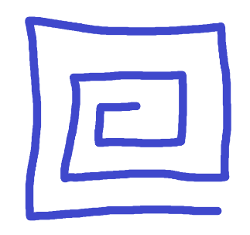
Fabric Prisma
Fabric Prisma is Prima imbued with the color of Fabrication.
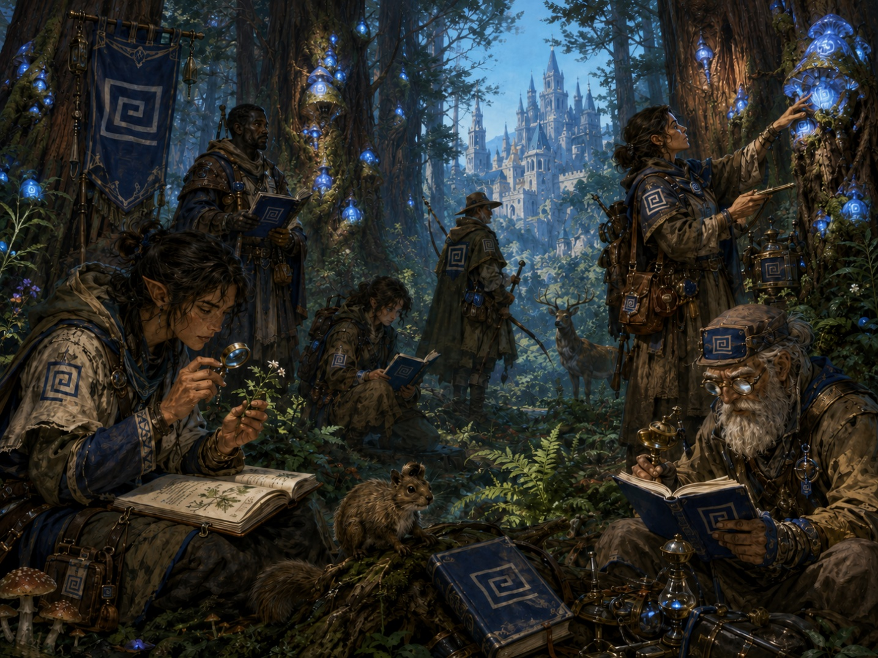
This rich blue Prisma presents itself as an atmosphere of fertility, organic life, and layered stories – very closely tied to soil, forests, and life. Cultures shaped by Fabric Prisma are defined as traditional, constructive, and sprawling. Visionaries who create grand structures woven into the landscape itself. Ancient kingdoms; visible far over the horizon containing sprawling archives of stories and artifacts – continuously iterating on the knowledge passed down with each generation; taking up space in the world culturally and physically.
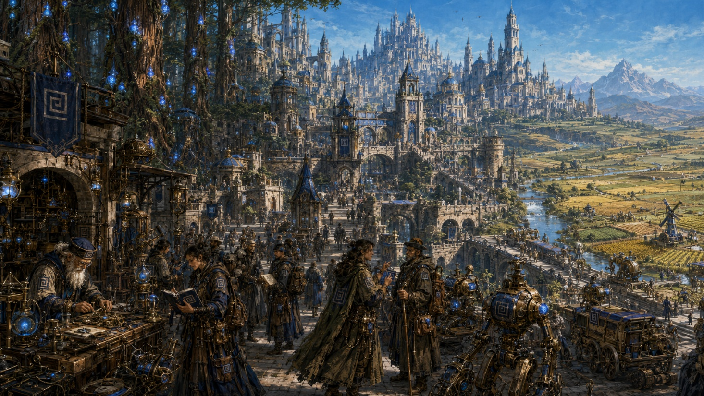
Prima is most potently stained with a Fabric Tint when it comes into contact with Loamstone; a hefty rock formed through the aeons of stone and decomposed matter being packed together. When refined, Loamstone manifests as an amber glass or metal with a subtle orange undertone and lends itself well to sturdy and Prisma-infused artifice, such as gauntlets, armor, shields, and edifice.
Fabric Prisma is closely tied to Body – an attunement to the organic, physical self – and Artifice – expression through material and abstract artifacts

To be born with a deeply blue font is to be blessed by the Deity Fabros

Fabric Prisma is associated with the following traits:
Steadfast, Visionary, Meticulous, Traditionalist, Generous, Loyal, Nurturing, Talented, Proud, Territorial, Acquisitive, Stubborn, Rooted, Sentimental

Fabric casters tend to have a natural inclination toward:
- Earth, Stone, and Organic Matter

- Healing and Protection

- Nature and Druidry

- Artifice and Constructs

- Empowerment of the Body

Fabric warriors tend to have a natural inclination toward:
- Absorption of force through physical robustness, expertly crafted artificer’s gear imbued with Prisma, and conjured earthen, metal, or organic constructs

- Tactical Advantage by taking up space and manipulating the landscape

- Healing Effects and Physical Empowerment to keep themselves and allies in the fight

- Sophisticated Artifacts, Conjured Gear such as Earthen Gauntlets, and Prima-Imbued Armor with various gadgets and gizmos

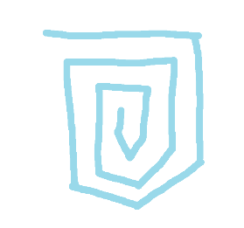
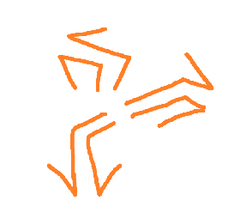
Higher Order Prisma
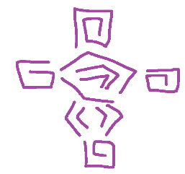
Morphic, Entropic, and Fabric - the three lower domains – serve as the basis for Prisma theory as a whole, and act as the primary colors through which Prisma is mixed and measured. However, as previously mentioned – every interaction with the world stains Prima to some degree. Stormy seas rich with tidestone, home to a fickle and mercantile culture, are Morphic for all meaningful intents and purposes – the atmosphere buzzing with an electric yellow hue, the denizens able to conjure sparks from their fingers and winds from their hands as an innate part of everyday life. But what about a Volcanic Island? Where Tidestone blends into Cinderstone? Where entropic wildfire meets fierce, tidal storms? Where the culture might be a Nomadic, Progressive Clan of Fierce Warriors?
When put under a microscope, it’s made obvious that no Prisma is stained with any single color. Bright yellow Prisma might granularly be 95% Morphic, 3% Entropic, 2% Fabric in Nature – which is still entirely fine and good for casting a spell defined as Morphic. But what about the aforementioned Prisma stained 48% Morphic, 47% Entropic, and 5% Fabric?
This is where we get into the Higher Order Domains; Prisma that sits between the Lower Orders with properties of both. This Morphic and Entropic blend of Prisma becomes something else entirely – electric and fiery; dynamic and all-consuming. In this example specifically, we’d see a bright orange type of Prisma known as Animus, or Animated Prisma. Animus represents the Force - the projection of physical and mental will – that Morphic and Entropic Prisma share. See the reference chart below for a quick visualization of these combinations

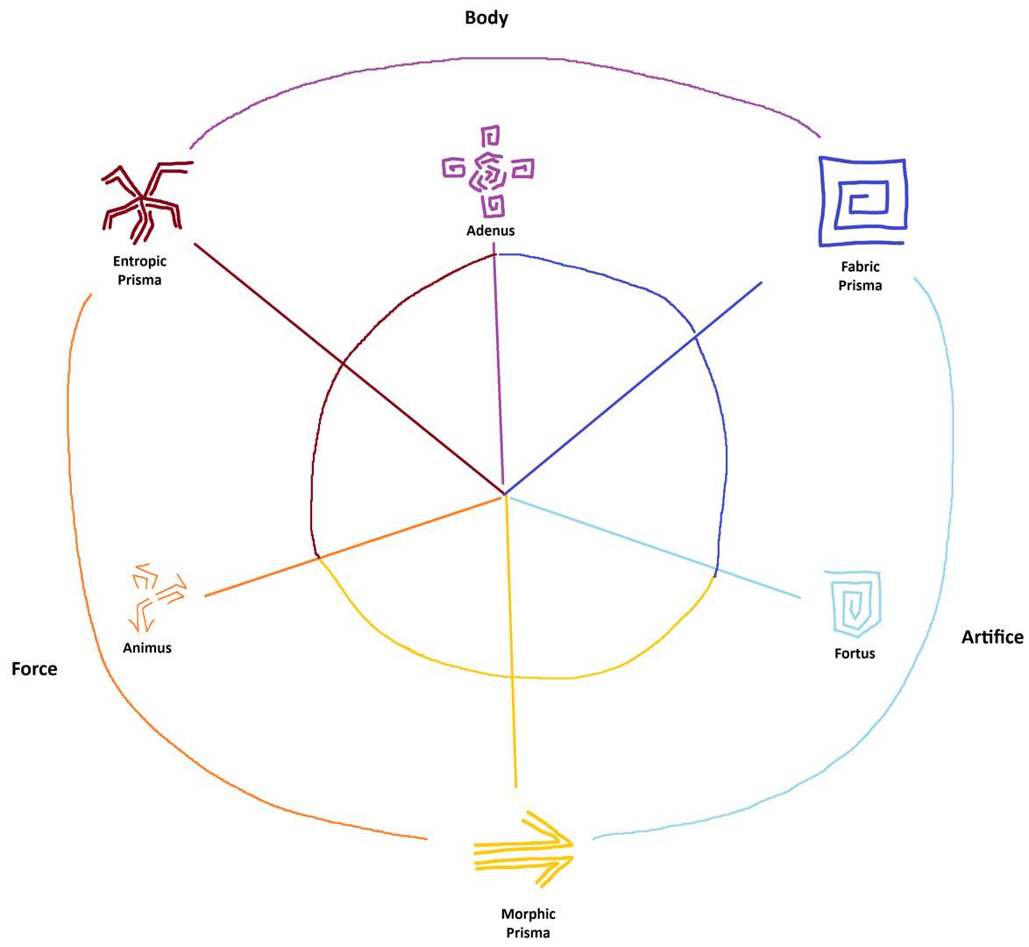
Higher and Lower Order Domains and the way they interact and blend serves as the foundation for determining one’s own personal attunement, as well as the language for understanding how Prisma can be applied into practical application. A skilled Artificer will want to locate themselves on a hotbed of Fortified Prisma – or Fortus – to most effectively craft potent, complex armor and tools. The Higher-Order Domains are as follows:
Animated Prisma
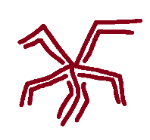
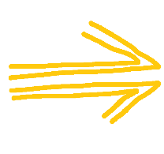
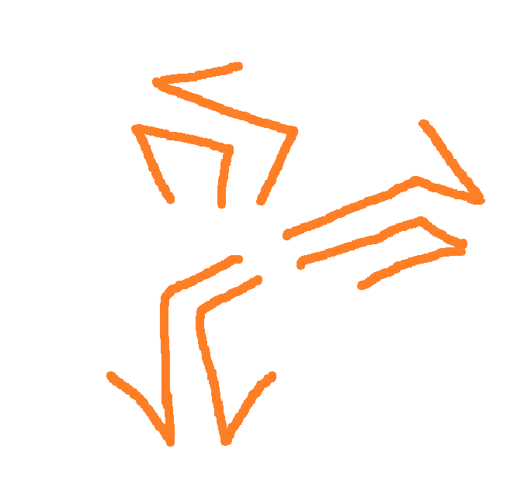
Animated Prisma is Prima deeply stained by Force.
The Animus domain is where the dynamic, electric nature of Morphic Prisma meets the all-consuming, fiery nature of Entropic Prisma. It encompasses the manipulation of primal natural elements. Fire and Ice; Wind and Water; Gravity and Corrosion. As a result, environments rich with this Prisma have a chaotic temperature gradient, with a looming feeling of something bigger over the horizon. Many have described it as ‘the feeling of an oncoming storm, yet arcane in nature.’
Animated Prisma is found where Entropic and Morphic Prisma converge. Volcanic Islands; Undersea Volcanic Trenches; Fields torn by Wildfire, slowly coming back to life through wind and rain.
Societies in these regions tend to be Nomadic and Fierce, opposed to the idea of building enduring cities and structures. They often rely on bartering systems when goods are absolutely needed – generally preferring to treat every problem that arises as a nail to be hammered through overwhelming elemental force.
This Prisma is entirely detached from Body (the organic, physical self) and Artifice (expression through enduring material and abstract artifacts)
Those born with a deep orange hue are said to cursed by a lifelong tug-of-war between the deities Morphos and Entropos.

Animated casters tend to have a natural inclination toward:
- Advanced Elemental Control and Manipulation

- Gravity and Spatial Manipulation

- Hexes and Curses

- Fire, Magma, and Decay

- Lightning, Wind and Water

Animated warriors tend to have a natural inclination toward:
- Powerful Auras of Pure Prisma, covering the body in elemental energies that dish out damage and absorb force of oncoming blows

- Reactive counter-magic. Damage Avoidance and Redirection

- Tactical Advantage through a flexible array of elemental spells to target opponents’ weaknesses

- Overwhelming offense compounded to win through raw damage output, compounded by hexes to cripple or create weak points

- Rudimentary Weapons and Light Armor, if any. Channel Prima directly through Willpower and Athletic ability.

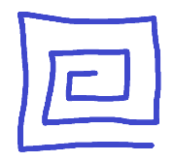
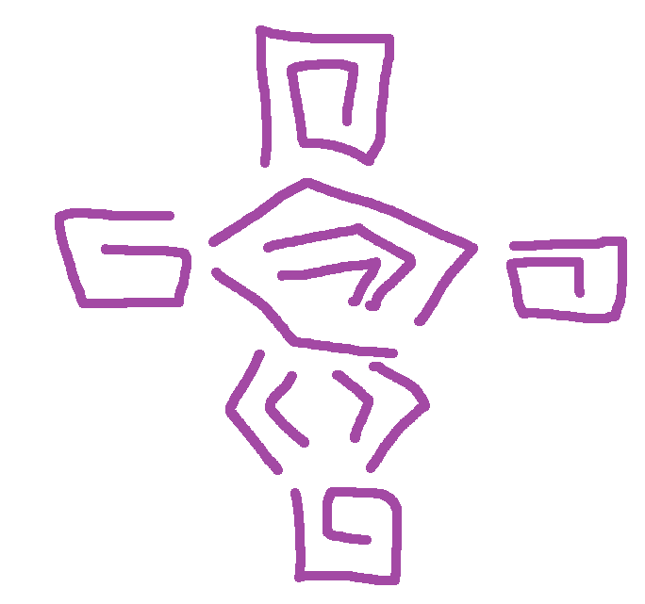
Invigorated Prisma

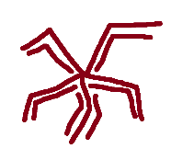

Invigorated Prisma is Prima deeply stained by Body.
The Vigorus domain is where the sturdy, earthen nature of Fabric Prisma meets the all-consuming, fiery nature of Entropic Prisma. It represents Prisma applied directly to the Body. Performing Physical Feats beyond one’s natural limits. An unshakable mind; impenetrable from hexes and curses. As a result, environments rich with this Prisma have an invigorating feel; clearing the mind and deeply filling the lungs with every breath, tingling against the skin itself.
Invigorated Prisma is found where Fabric and Entropic Prisma converge. Mountaintops shaped by aeons of cooled volcanic activity. Vast, contradictory floating islands – precarious yet steady in the sky. Regions rich in the fossilized remains of fierce predators.
Societies in these regions tend to be Earnest and Disciplined, often built around Temples, Monasteries, or Tribal Grounds. They tend to be philosophical and minimalistic; overcoming the outside world through a reliable and deep confidence in the self.
This Prisma is entirely detached from Force (projection of physical and mental will) and Artifice (expression through enduring material and abstract artifacts)
Those born with a purple hue are said to be cursed by a lifelong tug-of-war between the deities Fabros and Entropos.

Vigorous casters tend to have a natural inclination toward:
- Advanced Empowerment of the Body

- Death and Necromancy

- Healing and Protection

- Earth, Stone, and Organic Matter

- Fire, Magma, and Decay

Vigorous warriors tend to have a natural inclination toward:
- Physical Dominance, pushed past the normal limit with enhancement and manipulation of self

- High Physical Robustness and Mental Resilience with a massive reserve of stamina for long fights

- Tactical Advantage through tanking attacks on the frontlines and dealing crushing blows after closing the gap on enemies

- Healing and protection to keep themselves and allies in fighting shape, and Necromancy to remind even long-dead beings of the vigor that once filled their bones

- Live on the extremes of either the body itself as a weapon, or heavy martial weapons such as Great Axes and Broadswords to leverage robust strength. Similarly, they either rely on minimal armor for maximum mobility or heavy armor and shields requiring great strength.

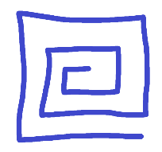
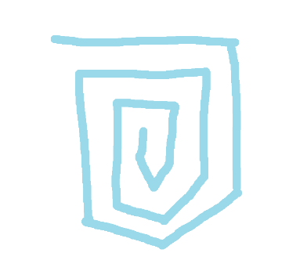
Fortified Prisma



Fortified Prisma is Prima deeply stained by Artifice.
The Fortus domain is where the sturdy, earthen nature of Fabric Prisma meets dynamic, electric nature of Morphic Prisma. It represents Prisma as a way of etching both material and abstract constructs. Creating floating prismatic barriers and summoning automatons and creatures into being. Crafting powerful, specialized artifacts and gear for any situation. As a result, environments rich with this Prisma feel both stimulating and pensive; with a controlled sort of motion that pushes the brain forward.
Fortified Prisma is found where Fabric and Morphic Prisma converge. Rivers which carve through ancient forests. Fertile plains hit by frequent tornados and storms. Fertile Jungles lining the seaside, whose ancient established ecosystems contrast the vagabonds riding oceanic currents.
Societies in these regions tend to be very skillful and value proliferation in some form. This might mean a kingdom on the cutting edge of innovation, greatly valuing their artificers and craftsmen, or societies that weave their Prima into the natural world and foster the growth of world trees and magical beasts.
This Prisma is entirely detached from Force (projection of physical and mental will) and Body (the organic, physical self)
Those born with a purple hue are said to be cursed by a lifelong tug-of-war between the deities Fabros and Morphos.

Fortified casters tend to have a natural inclination toward:
- Advanced Artifice and Constructs

- Nature and Druidry

- Enchantments and Charms

- Earth, Stone, and Organic Matter

- Lightning, Wind and Water

Fortified warriors tend to have a natural inclination toward:
- Complex, Engineered Equipment Imbued with Prisma to defend against a variety of situations, and summoned constructs of pure prisma, earth, or organic matter to block incoming damage

- Tactical Advantage through superior, personalized gear and battlefield manipulation with conjured artifice

- Charms to enchant allies with powerful positive effects, and summons to protect the entire team

- Sophisticated Artifacts, Weapons leveraging Crafty usage of Prisma and Skill over Brute Force, Prisma-Imbued Armor with various gadgets and gizmos

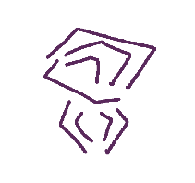
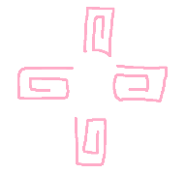
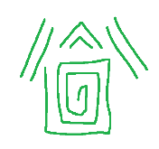
Special Order Prisma
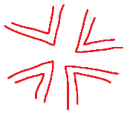
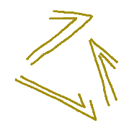
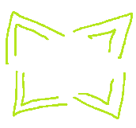
The Lower Order Prismatic Domains – Morphic, Entropic, and Fabric Prisma – are the most common and considered the most rudimentary forms of Prisma found in the natural world. Every environment in the realm can be categorized through an equation of Flow, Entropy, and Fabrication projected outward, with deeply yellow, red, and blue environments being the most plentiful and sprawling.
The Higher Order Prismatic Domains – Animated, Invigorated, and Fortified Prisma – sit in between each of the Lower Order Domains. Yellow meets Blue and becomes Orange. Red meets Blue and becomes Purple. Yellow meets blue and becomes Green. On the scale of mappable environments – continents, islands, and empires – and the spirits of creatures, these six categories are sufficient. Very few care to take the time to debate if an Animated Island technically has a 50% yellow, 40% red skew – the atmosphere is tinted orange, it carries a chaotic temperature gradient, and it behaves like Animated Prisma; the slight bias toward flow is a rounding error on the scale of entire cultures.

This mindset becomes very different – even lethal – if applied through the lens of craftsmanship. Whether an acolyte writing a spell that iterates on the classic ball of fire to “totally become the new standard across the realm”, an artificer balancing out the correct domain ratio to properly balance out the prismatic barrier of a magic breastplate, or an alchemist finely tinting prisma to create an entropic brew with a certain expected behavior, it is simply not sufficient to treat a 70% red, 25% blue, 5% yellow blend as a pure red tint. Errors like that – cutting corners, harvesting crudely tinted prisma from a random Cinderstone blend in the courtyard – is the fastest way to experience kickback; Prisma being used in a way that goes against its intent. Kickback can be as simple as a fizzled spell or wasted supplies. But when gravely miscalculated in a potent context, kickback can cause what is known as a catastrophe, which will be covered in more detail in the section on Channeling and Manipulating Prisma. For now, this concept is notable because it allows us to introduce the third and final category of Prisma – Special Order Prisma.

Special Order Prisma sits between Higher and Lower Order Prisma. Though it technically appears naturally in narrow and specific circumstances, the concept has very little usefulness in this regard. Special Order Prisma is classified by an Expression, or Dominant Domain, and an Inflection, or Supporting Domain.
Vigorus is a Higher Order Domain that broadly represents an even overlap between the constructive Fabric and destructive Entropic Domains. Empowerment and reinforcement of self is the Fabric aspect, and using the self to impose feats of strength and force is Entropic – an even blend of each domain.
Now, building off of that, adjusting this blend to either Entropic-Dominant or Fabric-Dominant results in two different Special Order Domains…
Necrus is the Special Order Domain that represents a higher ratio of Entropic Prisma and less Fabric Prisma. An Entropic Expression and a Fabric Inflection. Much like Vigorus, it is an expression of Body…but due to an Entropic Expression the resultant spells are Necromantic in nature. Necrus spells drain vitality from others and use it to bolster the self. They raise the dead – etching fabric creation onto entropic beings subjected to years of decay. Rather than permanently patching wounds, temporary healing patches wounds and decays over the course of combat. Entropic Prisma is the language in which these spells are written, but the font is tinted Fabric.
Now, let’s flip the script
Vitus is the Special Order Domain that represents a higher ratio of Fabric Prisma and less Entropic Prisma. A Fabric Expression and an Entropic Inflection. This is yet another expression of Body, but the Fabric Expression means that the resultant spells are Protective and Healing in Nature. Vitus spells grant vitality to and bolster others through one’s own Prisma. They dispel and burn the undead – dispelling fabric creation by etching entropic decay back onto them (A keen observer might notice the cyclical nature here with Necrus spells). Vitus spells dig into the body – as surgical procedure requires a controlled destruction of flesh – to build it back up and permanently patch wounds; healing in combat and beyond. These spells are written in the language of Fabric Prisma with a font tinted in Entropic Prisma.

The Special Order Domains of Prisma are the deepest useful classification of Prisma. Tools used to tint, channel, measure, and store Prisma do so on a scale that cleanly allows distinction between Lower, Higher, and Special Order Domains.
It is theoretically possible to endlessly and meticulously create spells with extremely specific effects, but in addition to the limitation of tools, these differences would be so granular and subtle that they would hardly be noticeable. A brigand would not care if an Animus ball of fire launched in his direction has a microscopically higher amount of Morphic Prisma than Entropic that gives it slightly more kinetic power and slightly less of a burn; it hurts either way.
Below is a chart mapping out the complete Prismatic Domains
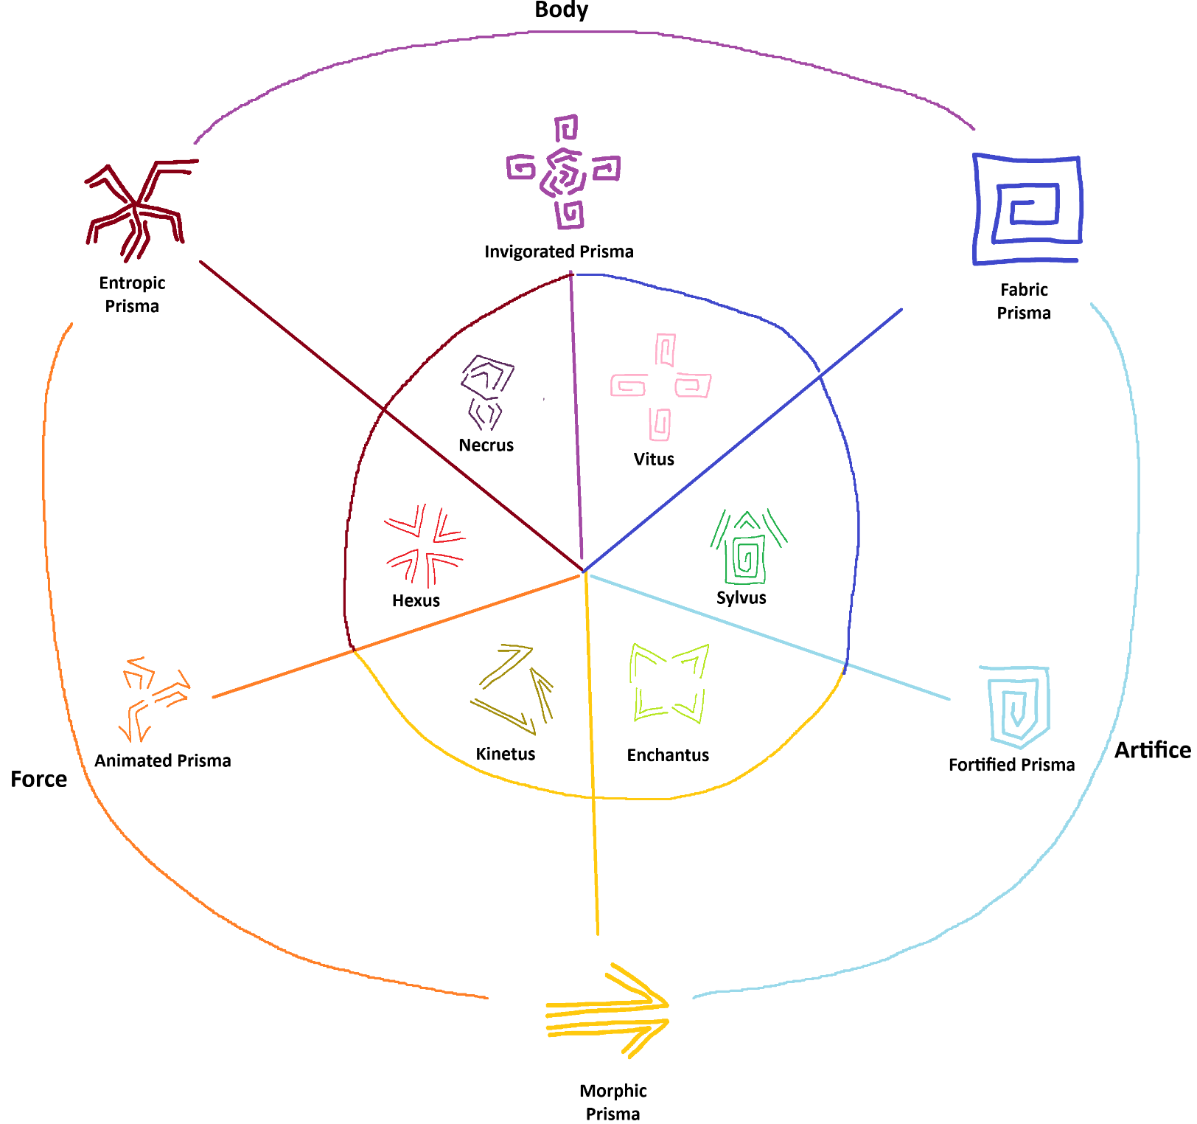
Domain | Expression | Inflection | Description
Vitus | Fabric | Entropic | Healing, Protection, Smites
Sylvus | Fabric | Morphic | Druidry, Organic Artifice
Enchantus | Morphic | Fabric | Charms, Enchantments
Kinetus | Morphic | Entropic | Gravity, Movement, Speed
Hexus | Entropic | Morphic | Hexes, Curses, Countermagic
Necrus | Entropic | Fabric | Life Drain, Necromancy

Many Emergent Truths and Philosophies emerge from close study of these domains. Entropic, Fabric, and Morphic Prisma being fundamental rather than composite is, perhaps, entirely arbitrary…Yet all existing literature, spellcasting, culture, alchemy, and artifice is understood through this language; it would take many lifetimes to create the tools and understanding necessary to assert otherwise.

Tying it All Together
Every being is born into this realm with a unique soul Fingerprint - channeling Prisma in ways shaped and understood by their Prismatic Domain alignment.
The most common case is a clear Lower Order Alignment – most populated regions, along with their constituent cultures and races, fall into some flavor of Morphic, Entropic, or Fabric - and in keeping with this, people instinctively pick up small, practical expressions of their domain: conjuring a spark as a party trick, flicking a flame to light a candle, or pulling a handful of mud from the earth for the garden.
A Fingerprint aligned to a Higher Order Domain is less common, but Animated, Fortified, and Invigorated peoples are still widely seen across the realm. Someone born into such an alignment might naturally learn to freeze water into a cube, conjure a small platform of Prisma to reach the top shelf, or push their arms just past their limit to lift a barbell one more time.
Special Order Prisma, however, is too precise and abstract to be mapped this way. Even societies with exactly the right confluence of domains to naturally produce Sylvan Prisma - and world-renowned Druidic traditions to show for it - are still classified and measured in terms of their Lower and Higher Orders.

Even who choose to life an ordinary life will naturally gain a deeper understanding of their own Prisma as time passes. This understanding unlocks increased potency and efficiency. Prisma is, after all, Stained Prima - and in this case, it is body and soul of the channeler doing the staining.
A loose connection to the self - a poor understanding of one’s own body and soul - makes the staining lossy and clunky . Clunky, because a weak intuitive grasp of each domain's nature causes what should be a single unit of Orange Prisma to instead become Red and Yellow mixed together. Rather than channeling Orange directly, the body reaches for one Red and one Yellow and combines them, losing Prisma in the conversion. Lossy, because even a clean attempt to channel Red Prisma may produce Yellow and Blue spillover - draining the body of far more Prima than necessary and accelerating fatigue.
Therefore, as one becomes more closely to themselves and the fundamental nature of Prisma, their functional reserve and its applications increase exponentially.
Those who choose to immerse themselves in lifelong pursuit of Prismatic Understanding - living exceptional lives of expertise and a deep exploration of self - are referred to as Channelers. The different Archetypes of Channelers, such as a Bright Orange Sorcerer or Deep Green Artificer, are referred to as Attunements.

